ELT Data Pipeline (Airflow + Snowflake)

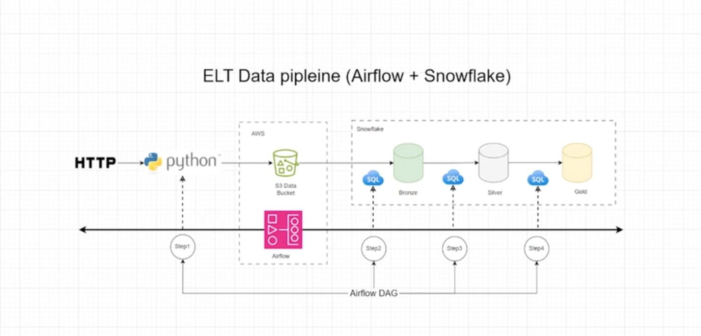

Objective: Using Apache Airflow on AWS to orchestrate --Extract, Transform and Load in a data pipeline.
Prerequisites:
- Two S3 buckets created. One bucket for data ingestion and one for DAG files for airflow
- External stage with S3 setup in Snowflake to ingest raw data from S3 bucket
- Creating Stored procedures in Snowflake to be referenced in python script DAG file.
- Apache Airflow setup on AWS using the automated cloud formation – connected to S3 and Snowflake.
Files Used:
- 4 SQL files created in snowflake:
  - Airflowproject_intialsetup.sql – This sets up schemas and external stage
  - Airflowproject_bronzetables.sql – Creates raw tables for data ingestion
  - Airflowproject_silverstoredprocedures.sql – Procedures created to transform data from bronze layer
  - Airflowproject_GoldStoredProcedures.sql –Procedures created to perform final transformations(aggregations) with new tables created.

- 3 files used for DAG processing:
  - Airflow_Snowflake_Test.py -- A simple DAG to test connection between Airflow and Snowflake
  - HealthCare_ELT.py –- The main DAG file used to orchestrate all layers in snowflake using the store procedures created in SQL files.
  - Requirements.txt – requirements needed for Airflow to connect with Snowflake

Workflow:
- Using python script as a DAG in Airflow, we bring in raw data from HTTP(GitHub) and upload it into S3. This S3 bucket is already setup as an external stage in Snowflake.
- In step 2 of the Airflow DAG, data is copied into bronze level tables as raw data using a Snowflake stored procedure, ready for next level of transformation.
- In step 3, the DAG is going to run transformation SQL code to clean and normalize the data using a Snowflake stored procedure, ready for final gold layer.
- Lastly, in step 4, data from silver layer is used another stored procedure to run aggregations on data for the gold layer. Data is now ready for business analysis.

